Name : Dev Adnani  
SID : 202212012

Subject : Systems Programming

Assignment : 1

Q1 : Change the permission of abc.sh to allow read, write and execute

permission for the current user but only read and execute for the group

and other users

Command :

Change Permission : chmod 755 abc.sh

Check Permission : ls -lrt

Screenshot :

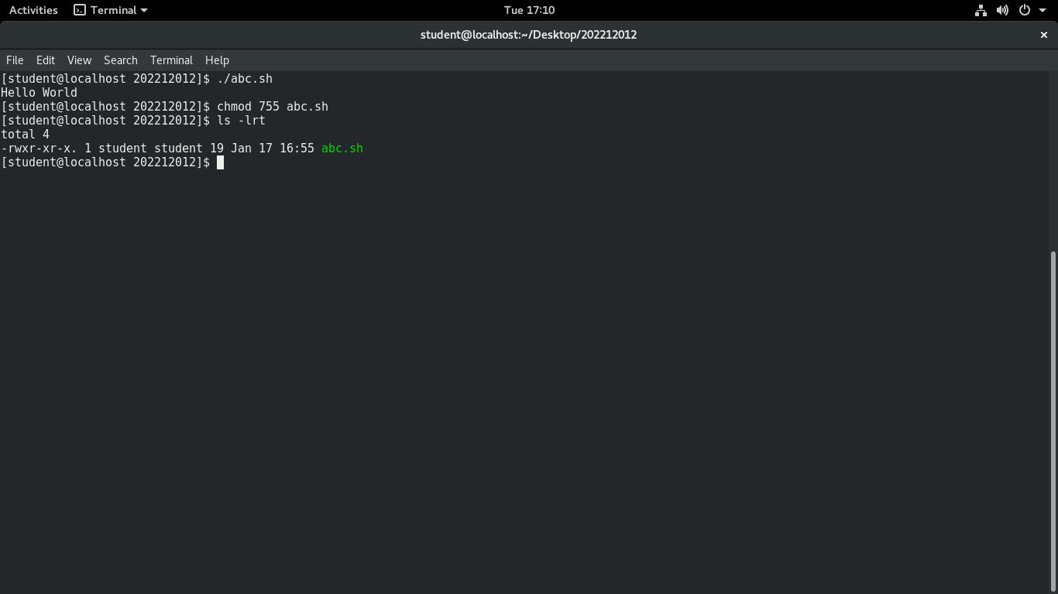

Q2 Display the OS and kernel versions that your system is currently running.

Command :

uname -ra

Screenshot :

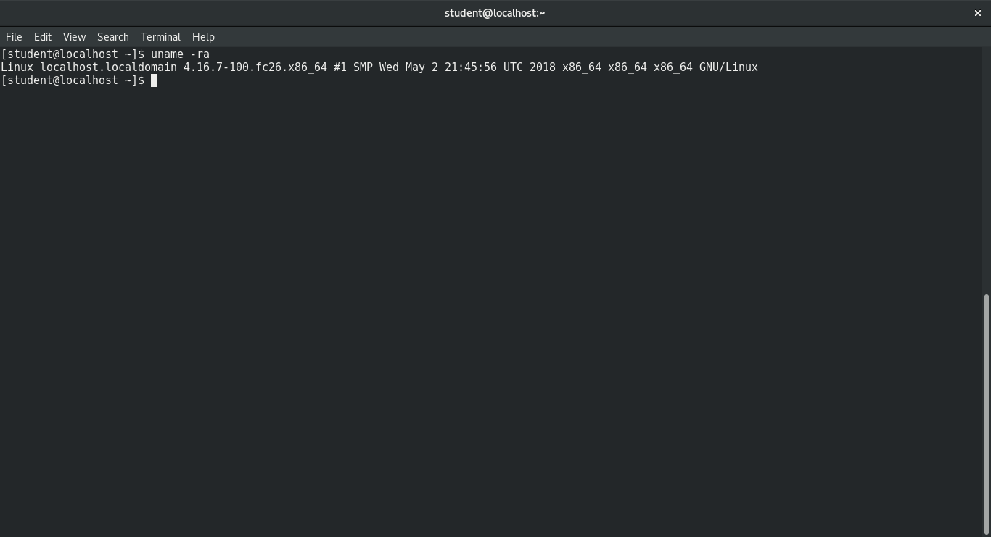

3:First, create two text files in1.txt and in2.txt using some editor (Gedit, Vi,

etc.). Create a new directory MyOut in the home directory and create a

third file out.txt in MyOut, which has combined content from both the

input files. (Hint: use redirection operators)

touch in1.txt

touch in2.txt

mkdir MyOut

cd MyOut

touch out.txt

cd

cat in1.txt in2.txt >> MyOut/out.txt

Screenshot :

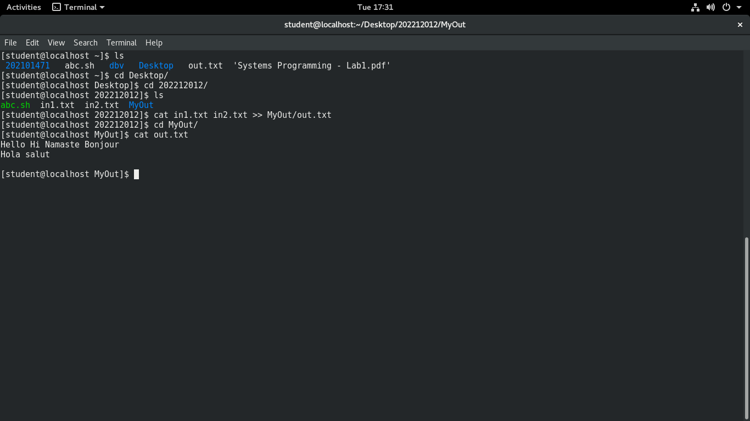

4: Search for a given word in all the three text files (in1.txt, in2.txt and out.txt)

Command :

grep -rnw . -e "Hello"

Screenshot :

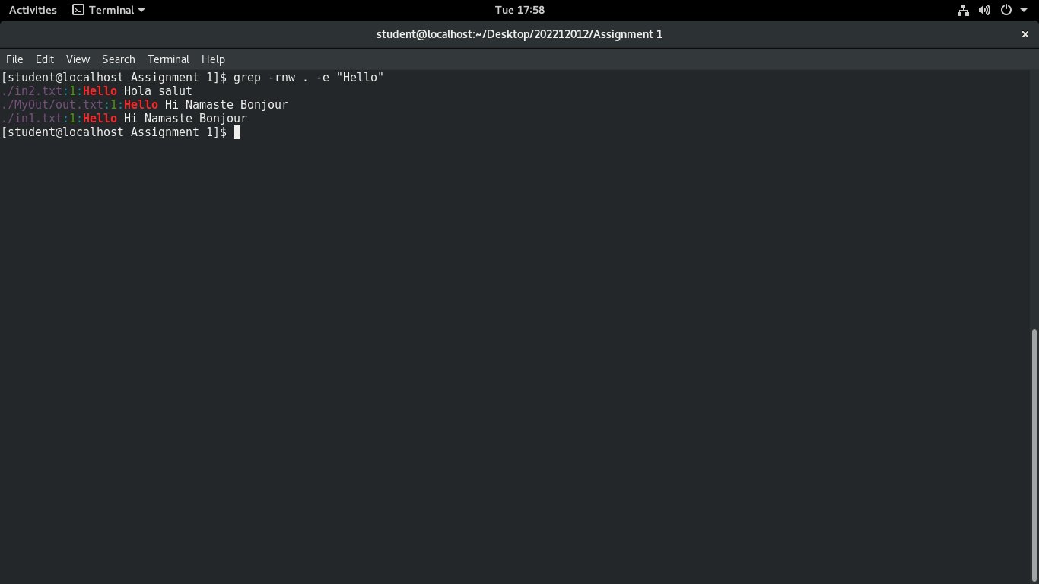

5: Using the awk command, display the current directory's total size, including

all subdirectories in MegaBytes.

Command :

ls –ltr | awk '{total += $5}; END {print "Total Size: ",total/1024/1024}'

Screenshot :

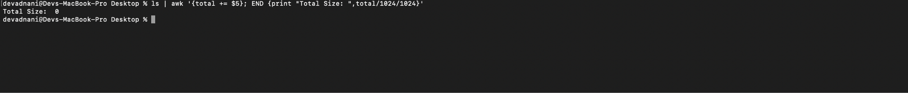

6: Display only the time part using date and cut shell commands.

Command :

date | cut -d' ' -f4-7

Screenshot :

